Explanation of V0.0.4
Project 9 — Predicting Road Condition
Final version — what each command does and what its output means

What V0.0.4 is
V0.0.4 is the complete project. It predicts what condition a road will be in at its next inspection, and then explains that prediction in plain English.
There are three commands. Everything else is handled automatically.
Command | What it does
./run.sh | Builds the data, trains every model, scores them and produces all the charts
./run_llm.sh | Lets you choose a road and writes a readable brief about it
./run_llm.sh test | Runs the safety checks that prove the briefs can be trusted

A note on Python files
Throughout this document each command is listed with the Python files it runs. A Python file is simply a text file of instructions ending in .py. Nothing in the project is a hidden program — every file can be opened and read.
The files are organised by job rather than by size. One builds the data, one explores it, one trains each kind of model, one checks the written briefs. That is why a single command runs several files: each does one part of the work and hands on to the next.
Folders group them: src/ holds the modelling code, llm/ holds the brief writer, and tests/ holds the checks. A file named config.py holds settings every other file reads, so that a path or a setting is defined once rather than repeated.
New in this version: the brief writer is now interactive. It lists the roads available, you choose one, then choose which survey. Previously you had to already know a valid road and date. This was added after the client asked for the system to take input directly.

1. ./run.sh — building and testing the models
cd V0.0.4
./run.sh

This runs the whole modelling pipeline. It takes about two to three minutes. On the very first run it also sets itself up, which adds a couple of minutes.
Figure 1 — the full ./run.sh output, from the first stage to "=== Done ==="
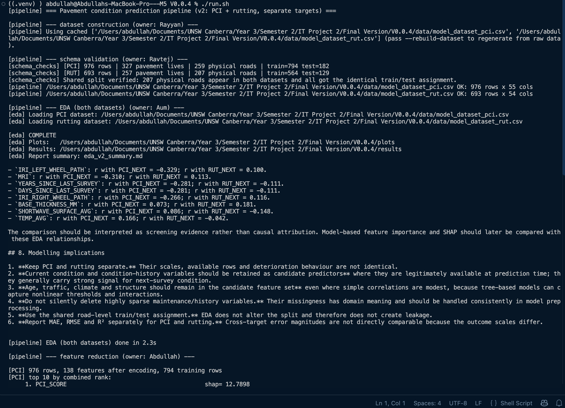
part 1 of 4 — data preparation, validation and exploration
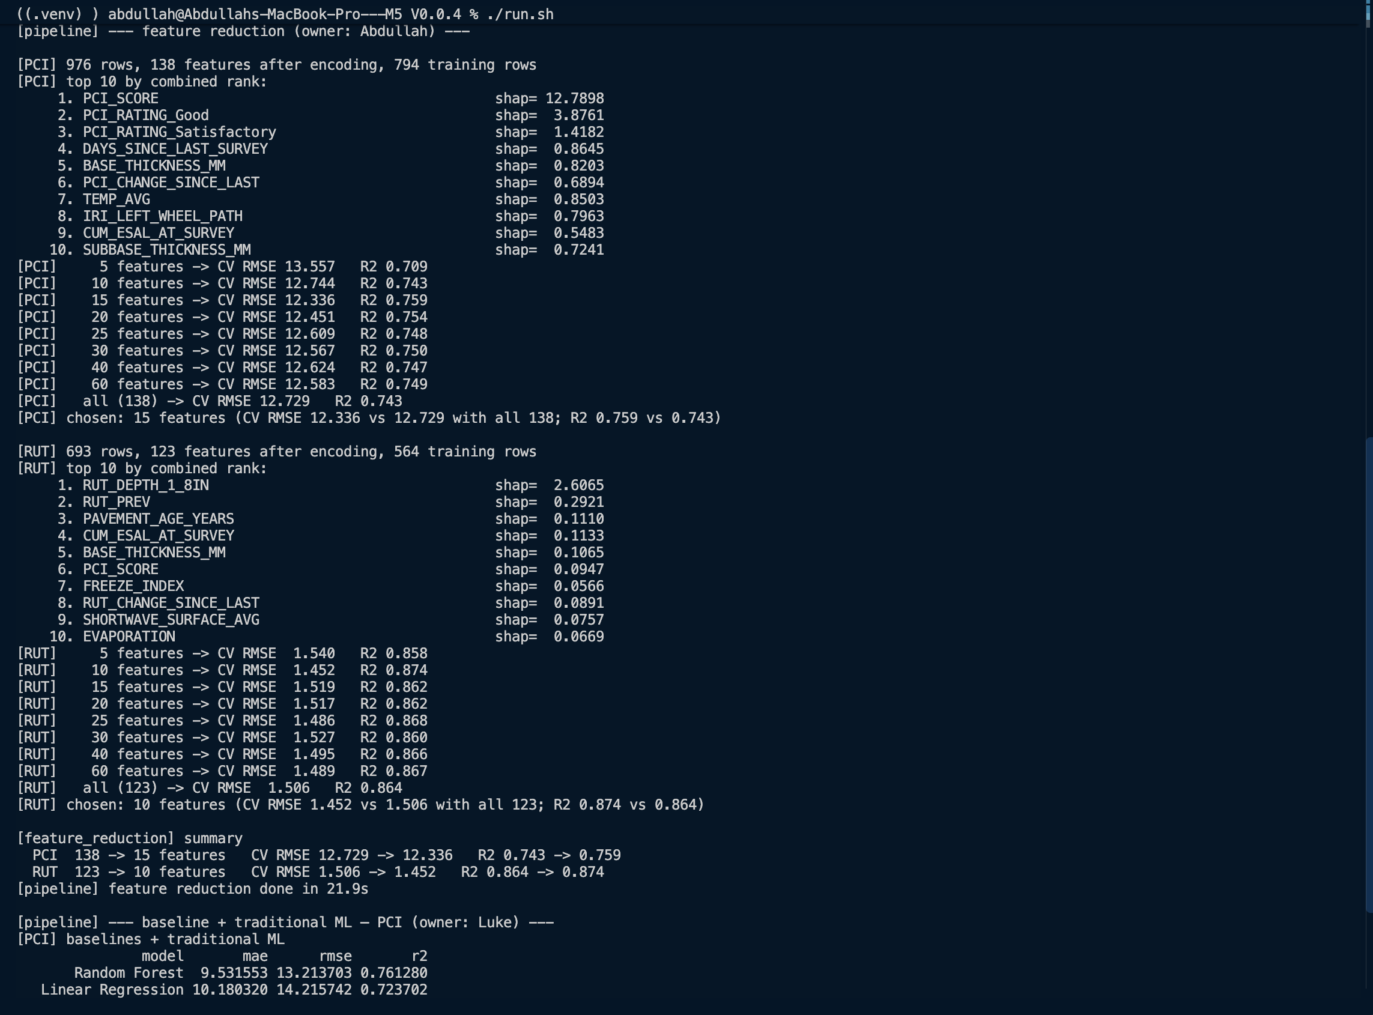
part 2 of 4 — feature reduction: 138 inputs down to 15
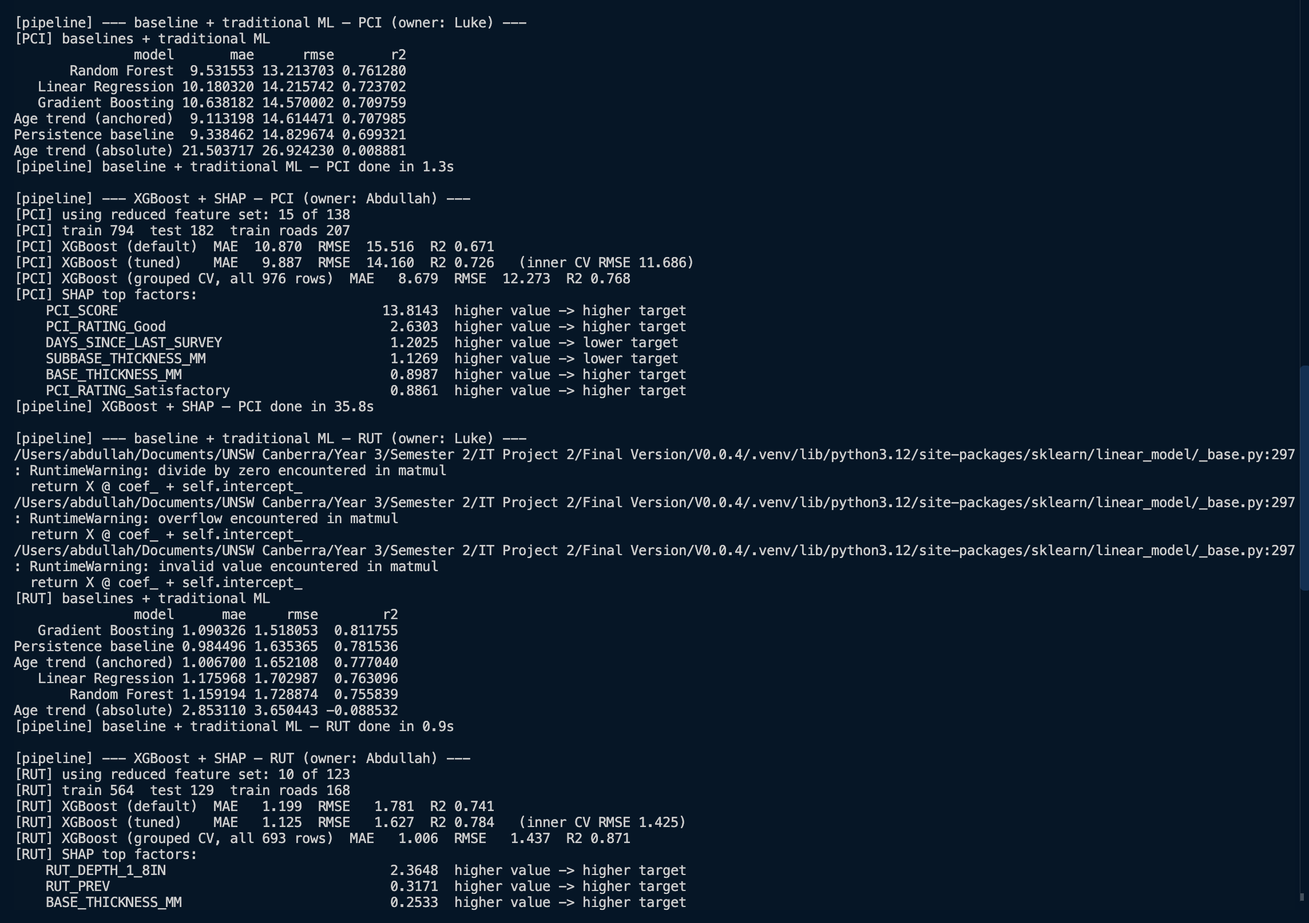
part 3 of 4 — the models being trained and scored
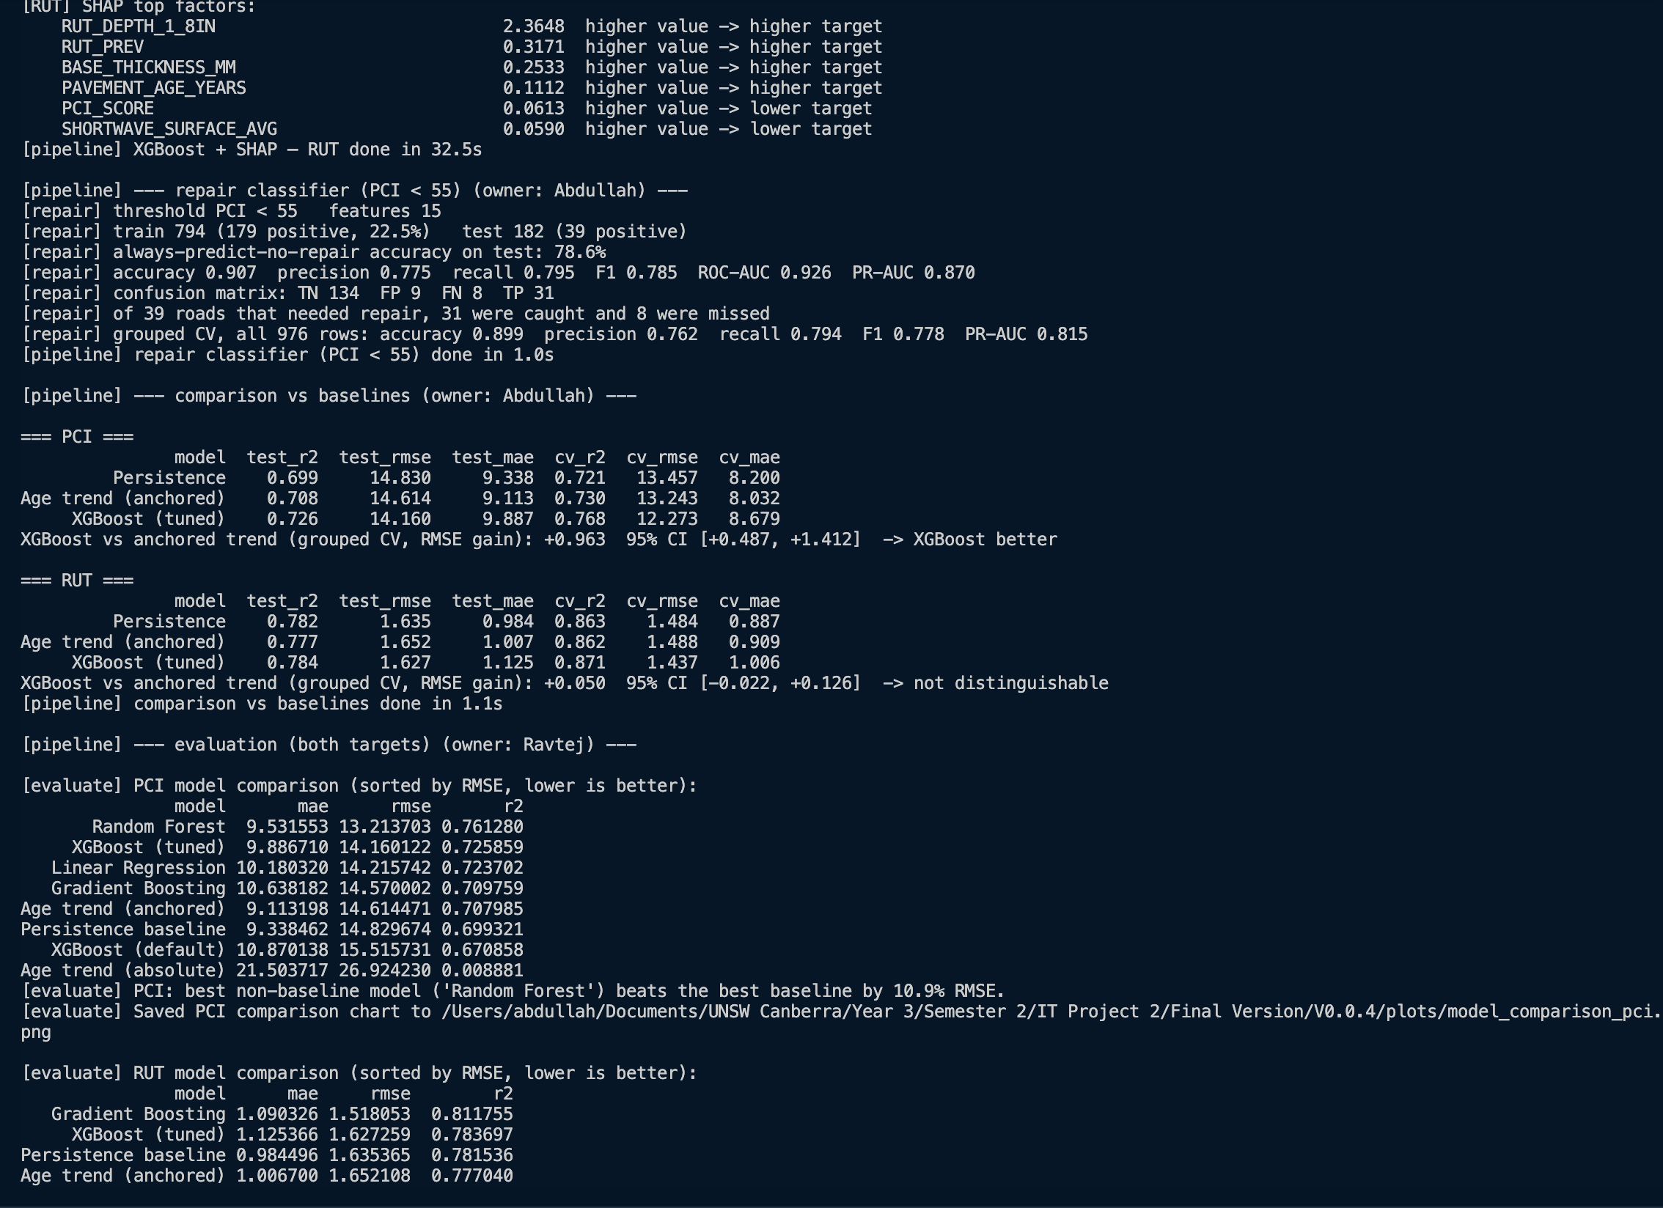
part 4 of 4 — repair classifier and the comparison against the baselines

What the output means
The run is divided into nine stages. Each one announces itself with the name of the team member who built it, then reports how long it took.
Stage | Who | What it is doing
Dataset construction | Rayyan | Building the two tables of road surveys the models learn from
Schema validation | Ravtej | Checking the data is complete and correctly split before anything else runs
EDA | Aum | Producing the charts and statistics that describe the data
Feature reduction | Abdullah | Working out which inputs actually matter and discarding the rest
Baselines + traditional ML | Luke | Five straightforward prediction methods, run for each target
XGBoost + SHAP | Abdullah | The advanced model, plus an explanation of what drives it
Repair classifier | Abdullah | Predicting which roads fall below the repair threshold
Comparison vs baselines | Abdullah | Checking whether the advanced model genuinely beats the simple ones
Evaluation | Ravtej | Collecting every result into one comparison table

Which Python files run
Eleven files, in this order. Each stage hands its results to the next.
# | File | What it does
1 | run_pipeline.py | The conductor. Calls each stage in turn and reports timings
2 | config.py | Settings every other file reads: where the data is, what is being predicted, the random seed
3 | src/schema_checks.py | Checks the data is complete and the split is sound before anything else starts
4 | src/eda.py | Produces the descriptive statistics and the charts
5 | src/models/feature_reduction.py | Ranks the inputs and keeps only those that matter
6 | src/models/baseline_traditional.py | The five simpler methods, including the two baselines
7 | results_io.py | Writes every result into one shared table so the methods can be compared
8 | src/models/xgboost_shap.py | The advanced model, and the explanation of what drives it
9 | src/models/repair_classifier.py | Predicts which roads fall below the repair threshold
10 | src/models/compare_vs_baselines.py | Tests whether the advanced model genuinely beats the simple ones
11 | src/evaluate.py | Collects everything into the final comparison tables

Three things worth pointing out in the output

- "Shared split verified: 207 physical roads appear in both datasets and all got the identical train/test assignment." This confirms no road was used both to teach the model and to test it. Without that, the accuracy figures would be meaningless.
- "138 -> 15 features, CV RMSE 12.73 -> 12.34." We cut the number of inputs by nine tenths and the predictions got slightly better, not worse. The discarded inputs were adding noise.
- The comparison tables at the end. Every method is listed, best first. This is the answer to whether machine learning beats simply assuming nothing changes.
Two numbers appear throughout. RMSE is roughly how far a typical prediction is off — lower is better. R squared is how much of the variation between roads the model explains, from 0 to 1 — higher is better.
Figure 2 — just the final comparison tables at the end of ./run.sh
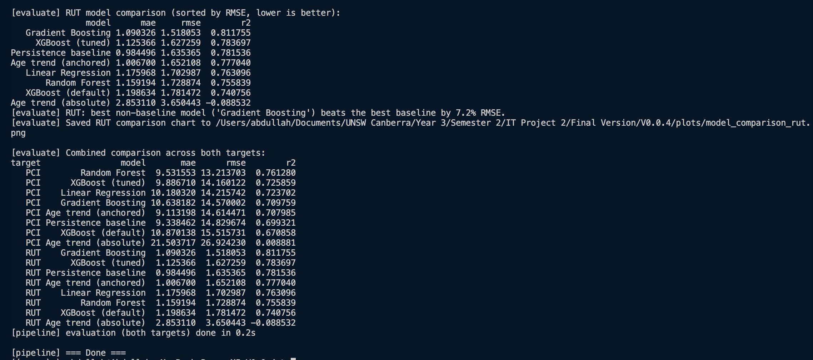
the final comparison tables, both targets, ending in "=== Done ==="

2. ./run_llm.sh — writing a condition brief
./run_llm.sh

With no arguments this is now interactive. It lists every road available, you pick one by number, then pick which survey. It then writes a brief about that road.
Figure 3 — the road list and the survey list, before the brief appears
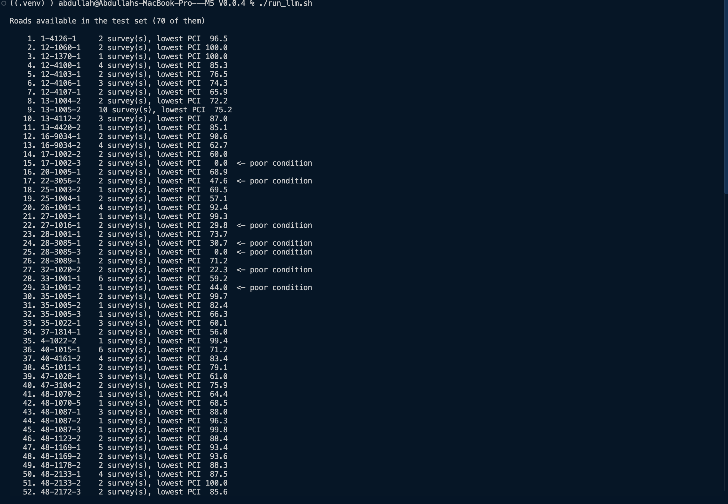
the road list — 70 roads, with poor-condition ones marked
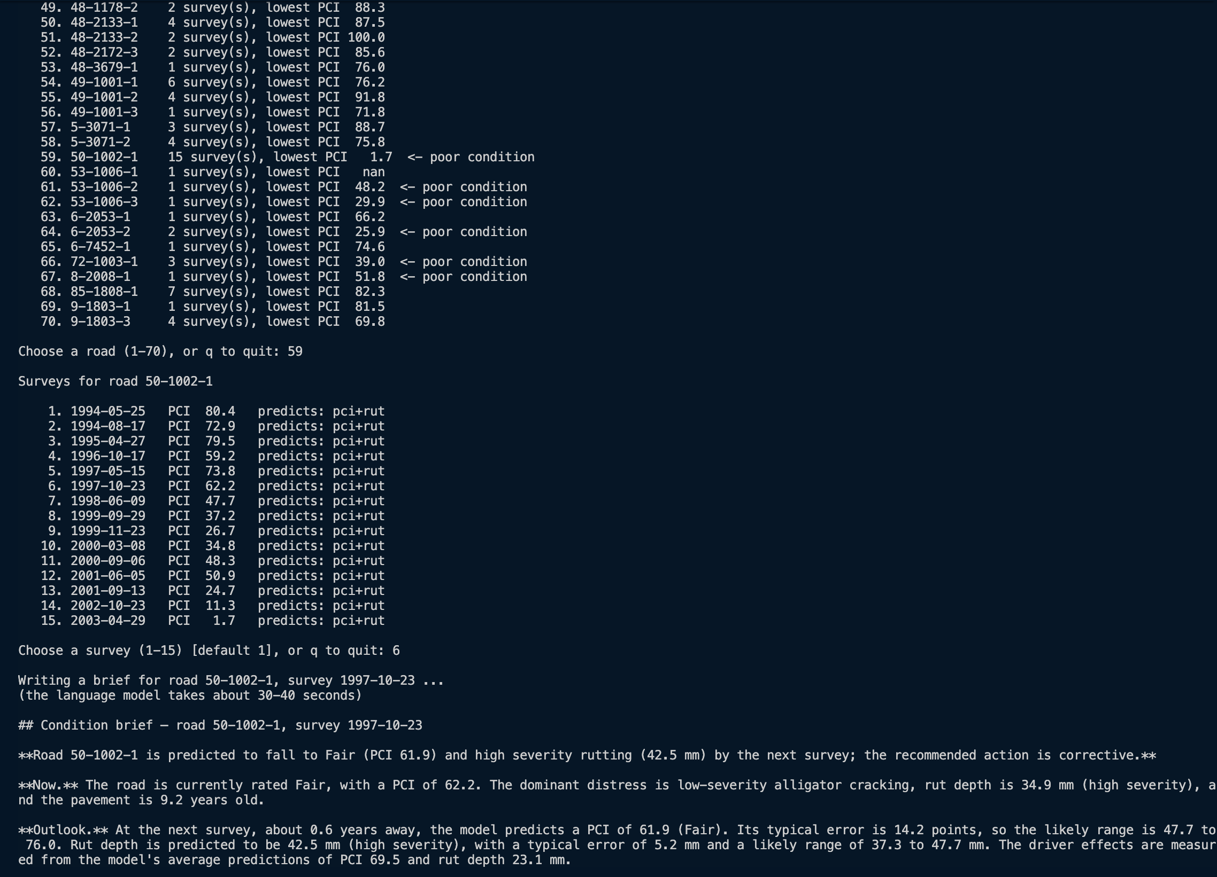
choosing road 59, then survey 6 of 15
The road list shows how many surveys each road has and its lowest recorded condition score, with poor roads marked, so there is something to steer towards.

The brief itself
Figure 4 — a complete brief for a road that the repair model flags
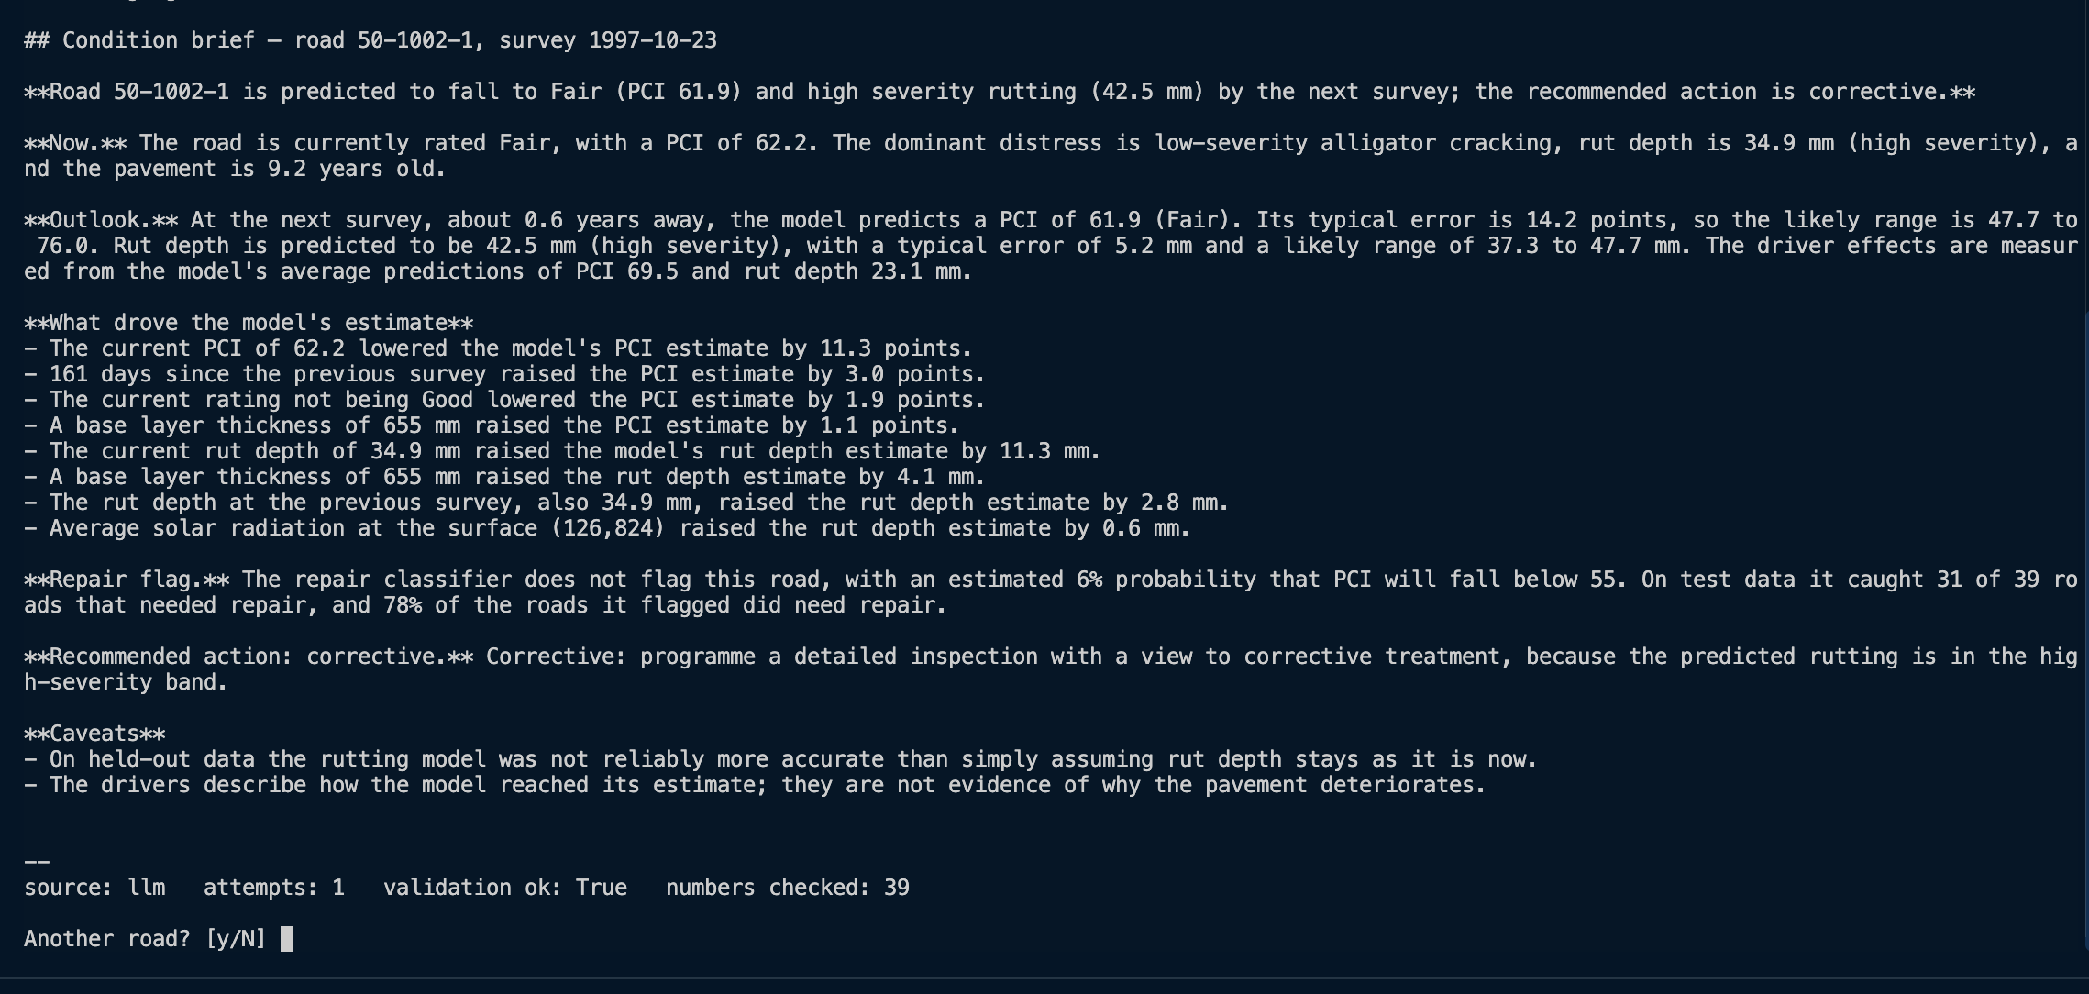
a complete brief: both PCI and rutting predicted, corrective action, 39 numbers verified
Each brief covers the same seven things:
Section | What it tells you
Headline | The outlook in one sentence, and the recommended action
Now | The road’s current condition, main type of damage, and age
Outlook | The predicted condition at the next survey, and the likely range around it
What drove the estimate | The four factors that most influenced this particular prediction
Repair flag | Whether the road is flagged as needing repair, and how reliable that model is
Recommended action | Monitor, preventive, corrective or investigate — and why
Caveats | What the reader needs to know about the limits of this prediction

Which Python files run
Fourteen files. Note that the three modelling files above do not appear — the brief writer loads the already-trained models rather than retraining anything, which is why a brief takes seconds rather than minutes.
# | File | What it does
1 | llm/interactive.py | Asks which road and which survey you want
2 | llm/brief.py | Runs the whole process: facts, then model, then checking
3 | llm/llm_client.py | Talks to the language model running on this computer
4 | llm/template_brief.py | The backup writer, used if the language model fails
5 | llm/payload.py | Works out all the facts in code, before the model is involved
6 | llm/v002.py | The only file that reaches into the modelling side for data and models
7 | config.py | The shared settings
8 | src/data/pci_algorithm_v2_reference.py | Turns a score into its rating band, and rut depth into a severity
9 | src/models/feature_reduction.py | Rebuilds the model inputs exactly as they were during training
10 | llm/features_lookup.py | Readable names for each factor, and converts units to millimetres
11 | llm/schema.py | Defines the seven fields the model is allowed to fill in
12 | llm/validate.py | Checks every number in the written text against the facts
13 | llm/prompts/brief_v2.j2 | The instructions given to the language model
14 | llm/outputs/briefs.jsonl | A log of every brief ever produced, for traceability

The line at the bottom — this is the important part
source: llm attempts: 1 validation ok: True numbers checked: 24

 | Meaning
source: llm | A language model wrote this. If it said "template" it would mean the backup writer was used instead
attempts: 1 | It got it right first time. No retry was needed
validation ok: True | Every number in the text was checked against our calculations and all of them matched
numbers checked: 24 | How many figures were verified. If any single one had not matched, the brief would have been rejected

Why this matters: the language model never produces a number. Our code calculates every figure first, the model only writes sentences around them, and then every number in those sentences is checked back against the calculations. That footer is the proof, printed on every brief.

3. ./run_llm.sh test — the safety checks
./run_llm.sh test

This runs 23 automated checks. It takes about two seconds and prints "23 passed".
Figure 5 — the test run showing 23 passed
23 passed in 1.89 seconds

Which Python files run
The same files as the brief writer, driven by the test file instead of by a person. That matters: the checks exercise the real code, not a simplified copy of it.
File | What it does
tests/test_llm_layer.py | The 23 checks themselves
llm/payload.py, llm/v002.py | Rebuild the facts and load the saved models, so the stored figures can be confirmed
llm/validate.py | The checker being tested — deliberately wrong text is fed in to confirm it is rejected
llm/schema.py, llm/template_brief.py | The output structure and the backup writer
llm/prompts/brief_v1.j2 and brief_v2.j2 | Both prompt versions are checked, so an old one cannot quietly break

What the 23 checks actually cover
They fall into four groups. The counts below add up to 23, so every check is accounted for.
Group | Checks | What it proves
1. The saved models reproduce the numbers we report | 3 | Nothing in results/ has drifted away from the models on disk
2. The maths behind the explanations is sound | 4 | The driver breakdown and the uncertainty range are arithmetically correct, not decorative
3. The language model is given the right facts and nothing more | 5 | The real future condition is never in the prompt, and both prompt versions still work
4. The validator catches a misbehaving language model | 11 | Wrong text is rejected before anyone reads it

Group 1 — do the saved models still give the right answers? (3 checks)
These reload the saved models, re-predict the held-out test roads, and confirm the error rates and the repair model's results table match the figures in results/ exactly. If anyone retrains a model and the numbers move, these fail immediately. That is not hypothetical — it is how we caught a bad run earlier in the project that had quietly overwritten the real results.

Group 2 — is the underlying maths sound? (4 checks)
The per-factor breakdown behind each prediction has to add back up to the prediction itself; that is checked for both PCI and rutting. The uncertainty range has to be exactly the prediction plus or minus the model's typical error, clipped to the 0–100 PCI scale. And a date written either way round — 1993-03-30 or 30/3/1993 — has to resolve to the same survey. These are verified rather than assumed.

Group 3 — is the language model given the right facts, and nothing it should not have? (5 checks)
The most important check in the whole file is here: it confirms the real next-survey condition is withheld from the prompt. Our code knows that value — we use it afterwards to score the brief — but it is stripped out before the model sees anything, so the model cannot work backwards from the answer. The rest confirm that an unknown road-and-date combination raises an error instead of guessing, that both prompt versions render against the correct road, and that the worked examples built into the prompts use training roads only, so we are never showing the model test data.

Group 4 — can the language model misbehave? (11 checks)
Each of these deliberately feeds the system wrong text and confirms it is rejected. This is the group that makes the LLM layer safe to put in front of a client.
The check | What it catches
Fallback brief always valid | The built-in template writer is checked against every survey in the test split, so the backup path can never be silently broken
Invented number rejected | Any figure that is not in the payload — the single most likely way an LLM misleads a reader
Rounded number accepted | Saying “about 54” when the prediction is 53.6 is allowed; we are not forcing false precision
Causal wording rejected | “will cause the road to fail” is blocked, because the model shows association, not cause
Raw JSON / field names rejected | Internal data structures cannot leak into prose the client reads
Brief with no prediction rejected | Vague reassurance that never states the actual forecast is not acceptable output
Imperial units rejected | We report millimetres; inches are blocked
Rutting overclaim rejected | Claiming the rutting model beats the persistence baseline is blocked, because it does not. The negated caveat our template writes is still allowed
Flipped driver direction rejected | Saying a factor raised the score when it lowered it
Wrong repair wording rejected | Text that contradicts the classifier's actual flag for that road
v2 prompt adds no new numbers | The newer prompt cannot smuggle in figures the payload does not contain

What these checks do not cover
They prove the system is reproducible and honestly described. They say nothing about whether the predictions themselves are any good — that question is answered by the comparison tables from ./run.sh, where each model is measured against the persistence and age-trend baselines. A green test run means we are reporting our results correctly, not that the results are impressive.

4. In one page
Command | What it proves
./run.sh | That the models are built correctly, tested fairly on roads they have never seen, and that machine learning beats the simple approaches
./run_llm.sh | That a prediction can be turned into advice a person can act on, with every number traceable back to a calculation
./run_llm.sh test | That the safeguards work — not just that the code runs, but that incorrect output is actually caught and rejected

5. Known limits
- Briefs can only be written for surveys that already exist in the data. The system cannot be asked about an arbitrary future date, because the models have no forecast-horizon input.
- The recommended action categories are provisional rules that still need the client’s confirmation.
- There is no graphical interface. Everything runs from the command line.
- If no language model is installed, the system still works but uses a fixed template. That is ordinary code, not a language model, and should not be presented as the AI component.

